**Lab 4 Exercise**

1. Ali went to visit his grandmother in USA, and she gave him 368 pennies as a gift. Carrying so many coins would be a hassle, so Ali wishes to convert the 368 pennies into a better format. Write a C program which converts the 368 pennies into a set of pennies, nickels, dimes, and quarters such that Ali has to carry the least amount of coins.

* 1 quarter = 25 pennies
* 1 dime = 10 pennies
* 1 nickel = 5 pennies

1. Write a C program to find the Euclidean distance between 2 points (x1, x2) and (y1, y2).

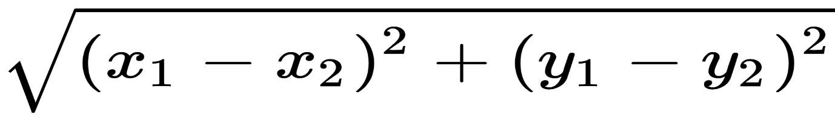

1. Write a C program to calculate dot product of 2 vectors (A, B) where:
   * A = (5,2, -3), B = (-4,9,2)
   * Angle between A and B is 53 degrees.

Implement it using this formula:

1. Write a C program to take a number as input and print 1 if the number is a power of 10, and 0 if it is not. (You cannot use IF condition or loops).
2. Write a C program to take a positive number as input and multiply it by 4 using only bitwise operators. (No loops allowed either).
3. Write a C program to take a positive number as input and multiply it by 13 without using the * operator. (No loops allowed either).
4. Write a C Program to Find Smallest of Three Numbers without using IF Conditions and loops.